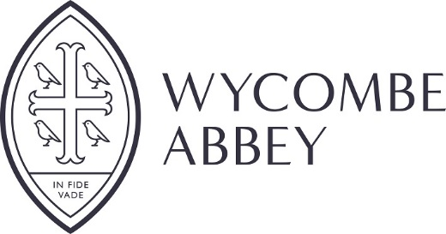
Job Description – Domestic Assistant
Aim: The post holder will be responsible to the Domestic Services Manager and the Domestic Team Leader working as part of a team to ensure a high standard of cleanliness and order is maintained in their designated area.
Reports to: Domestic Team Leader / Domestic Services Manager
Salary: £8.33 per hour.
Other benefits: Lunch during Wycombe Abbey School term time.
Use of the Davies Sports Centre at specified times.

Hours of work: 40 hours per week 6am – 2pm Monday to Friday for 52 weeks
(Hours include a 30 minute unpaid lunch break and a 15 minute paid tea break per day)
Areas of responsibility:
- At the beginning of term ensure all areas are clean and orderly ready for the teachers and girls return.

- During the term, maintain high standard of cleanliness and order to designated areas, with particular attention to hygiene in toilet areas.

- Remove and dispose of rubbish from designated areas.

- Cleaning of windows as necessary.

- At the end of term, working as a team, to ‘spring clean’ the designated areas including washing down walls and moving furniture to ensure a thorough clean.

- Carry out residential cleaning/cleaning of facilities during holiday periods.

- Any other duties required to help with the smooth running of the School.

Person specification
- Reliability

Able to follow directions from supervisors and respects policies and procedures. Able to show commitment to the organisation and task completion.

2. Team working
Ability to develop effective and supportive relationships with colleagues, both internal and external both in terms of social interaction and positive support with team workload.
3. Using initiative
Ability to work unsupervised and to take responsibility for own actions with a good attention to detail.
4. Customer focus
Able to build rapport easily, put the customer first and work hard to meet their needs.
5. Communication
Able to communicate effectively, verbally.

6. Flexibility
Successfully adapts to changing demands and conditions.
8. Special conditions
The post is conditional to an enhanced DBS check.
Holidays will need to be taken within the School’s holiday period.
Child Protection Statement:
The post holder’s responsibility for promoting and safeguarding the welfare of children and young persons for whom s/he is responsible, or with whom s/he comes into contact will be to adhere to and ensure compliance with the School’s Child Protection Policy Statement at all times. If, in the course of carrying out the duties of the post, the post holder becomes aware of any actual or potential risks to the safety or welfare of children in the school, s/he must report any concerns to the School’s Designated Lead for Safeguarding or to the Headmistress.
The School values of Mutual Respect, Encouragement and Trust (MET) should be followed to enhance working relationships and to benefit the whole School community.

